Stock Model:

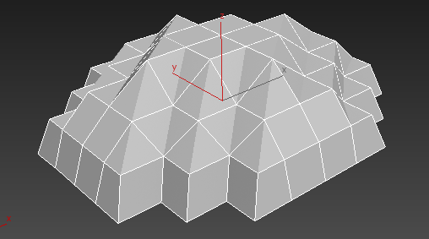

1st Method: Modifiers

In this method attempted to turn a normal model of an island into a low poly version suitable for our game.

With this method playing a lot with the geometry of my initial shape it became very untidy and not the finish I was hoping to achieve although with smoothing groups set up it still has defined line and looks okay

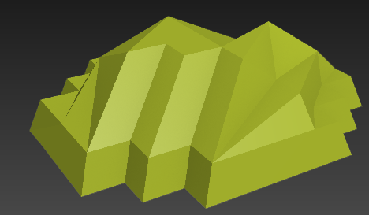

Photo showing how geometry changed.

2nd Method: Smoothing groups

In this attempt I looked at just adding smoothing groups to the model. With a very low tolerance it gave me the look I was after. Knowing now I can focus on texturing the island using smoothing groups and a stock colour texture should give a good overall look. And without any geometry changing it gave distinct edges and an overall nice look.

